Diagramas do chatbot.

DIAGRAMA DE COMPONENTES

link: https://claude.ai/public/artifacts/28f34b50-8676-40b5-bf51-a08f1f13a491
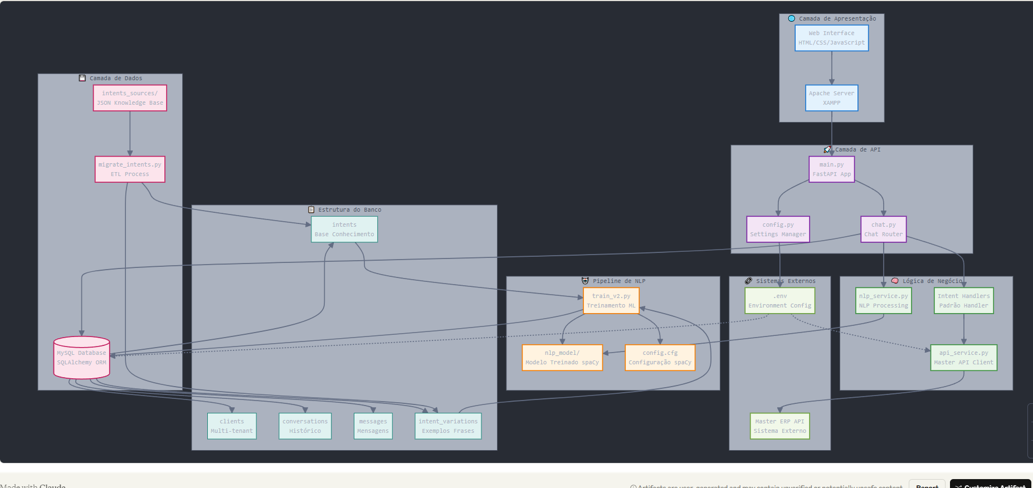

DIAGRAMA CASO DE USO.

Link: https://claude.ai/public/artifacts/0f771e12-2c2d-44c0-aa91-a324480127db
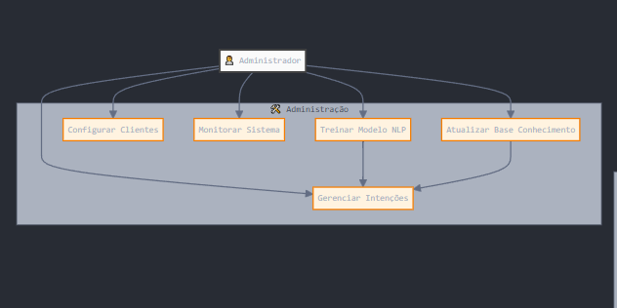
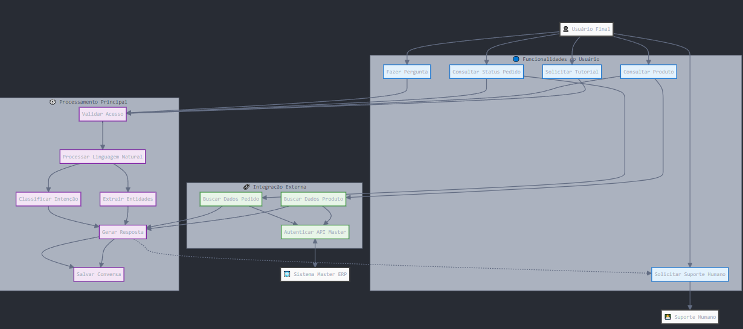

DIAGRAMA DE SEQUENCIA.

Link: https://claude.ai/public/artifacts/635ecb94-1488-4a4e-83cf-52098218eeb6

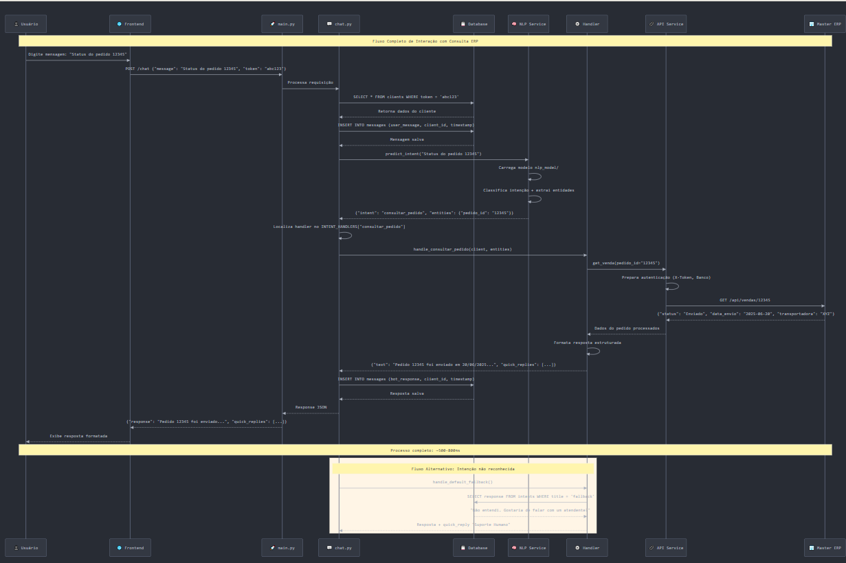

DIAGRAMA DE IMPLANTAÇÃO
Link: https://claude.ai/public/artifacts/043d981e-2b25-4893-90a1-36dc6a281727?fullscreen=true
